Literally: project #2
Element and Principle: Value And Contrast

Artist
Artemisia Gentileschi  - Lived 1593-1656  - Daughter of Orazio Gentileschi, heavily influenced by his artwork, and lost her mother at age 12  - Traveled from Florence to Venice to Naples  - She was the first woman ever admitted into the Accademia dell’Arte del Disegno in Florence.  - Used art to process her trauma  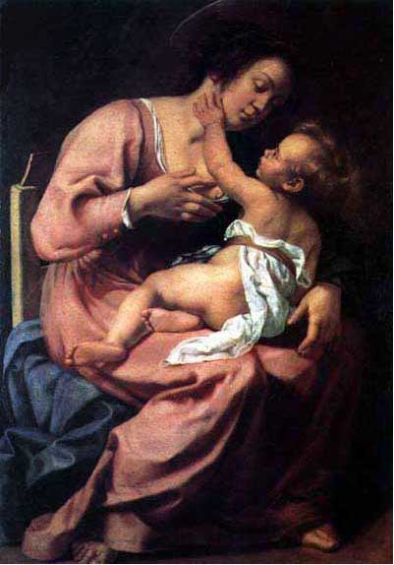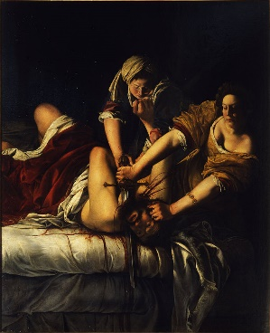 | 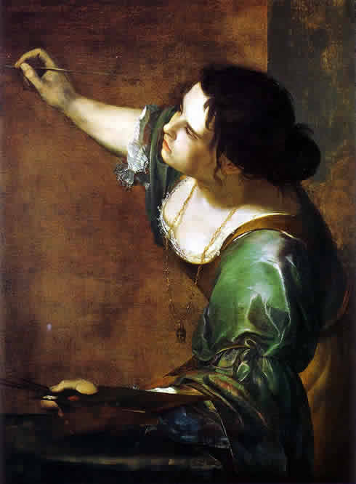

Instructions
Art 2
- Read Robert Frost’s “Directive”
- Annotate as needed. Find inspiration in the metaphors and figurative language
- Choose one quote to illustrate literally
- Must use charcoal and toned paper
- Write chosen quote on back of piece
AP/Advanced Art
- Choose something that you have assumed is true with absolutely no proof behind it. A self-drawn conclusion. Draw upon that assumption for inspiration

