Melted: project #3
Element and Principle: Balance, Space, Contrast

Artist
MC Escher  - Son of an engineer, pressured to study architecture  - Most famous for “Impossible Constructions”  - Used primarily woodcuts and wood engravings, as well as pen and ink drawings and sketches  - Considered himself first and foremost a graphic designer  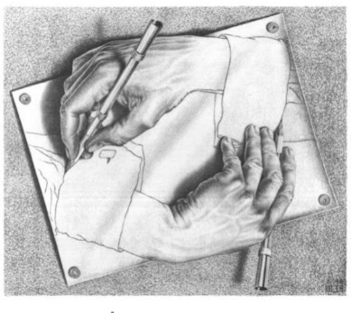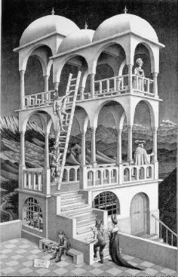 | 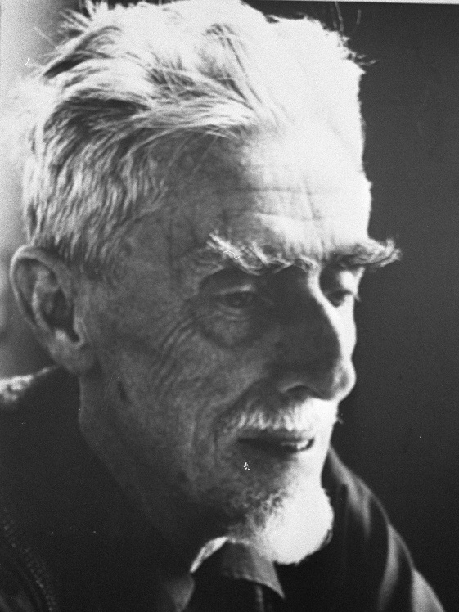

Instructions
Art 2
- Tone your cardboard using an “unconventional” method. Create three distinct sections
- Using the brainstorming method demo’d in class, choose one topic from each column to create into a melted triptych that combines a landscape, a portrait, and technology
- Your piece must create a narrative
AP/Advanced Art
- Tone your background using an “unconventional” method. Create three distinct sections.
- Using the brainstorming method demo’d in class, choose one topic from each column to create into a melted triptych that seamlessly melds together
- Your piece must tackle a political or personal issue

