Monochrome
Element and Principle: Value, Balance, Rhythm, Control

Artist
Pablo Ruiz y Picasso  - Spanish painter, sculptor, printmaker, stage designer, poet, playwright  - Spent most of his adult life in France, especially Paris  - Developed from realism to surrealism to cubism  - Many of his pieces are inspired by the Spanish Civil War  - Most famous for his development of the Cubist style | 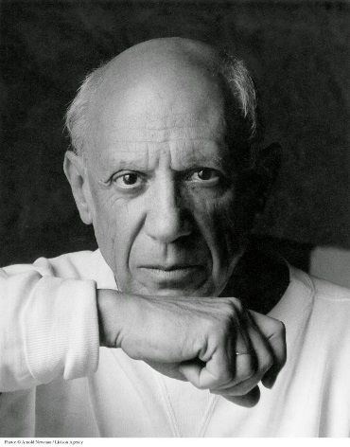

Instructions
Art 1
- You will be creating a triptych, pop-art still life
- On tracing paper, draw a still life with at least five objects
- Measure a 1” border on the provided matboard, then divide into three
- Using the technique demonstrated, transfer your still life drawing three times
- Use only your chosen color to create the values you see on your objects
- You may use objects from your backpack, objects you bring with you, or objects in class
- If you need to soften gradients, use a SMALL amount of water
Monochrome Tips
- Use one color and mix either black or white with color to create all of the differing tones in your piece.
- Black and white images make helpful reference photos
- Flat brushes will help with straight lines
- Be heavy with the paint! You need very little water
